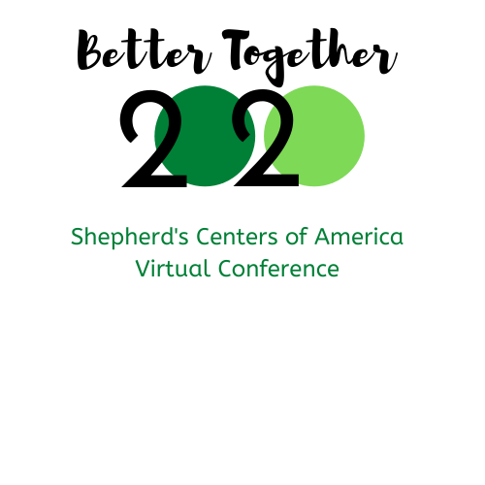
Wednesday, October 21
Reframing the New Normal

1:00 PM ET | Conference Kickoff!
1:15 PM ET | Primer for Reframing the New Normal  A look at Shepherd’s Center Founder Elbert Cole’s values and vision, how these shaped our model for inclusivity, and how we must continue to strive for equity.
1:30 PM ET | Keynote  Diversity, Equity and Inclusion: Shifting From Blind Destructiveness with Dr. Nicole Price, Founder Lively Paradox  No topic elicits anxiety more than a session about diversity, equity and inclusion. This keynote manages to garner interest and excitement while reducing anxiety about the work to come. Dr. Price will make sense of all the leadership wisdom we’ve been given by first distinguishing the vast differences of intent versus impact and how this distinction is wildly important when embarking on diversity initiatives.
2:30 PM ET | Short Break
2:40 PM ET | Concurrent Sessions
 | Volunteer Management in a Changed World with Katie Campbell, CVA, Skye Consulting  Volunteers remain at the center of our organizations – but the new realities around us require significant changes in how we involve, manage, and support them. This session will review the current landscape affecting volunteers, revisit effective practices, and provide practical ideas for adaptation and innovation. | Defining Board Roles During a Crisis with Callen Brown, Northeast Florida Nonprofit Association  How a nonprofit responds during a time of crisis can greatly impact its short-term standing and long-term sustainability. What role does the board play – from ensuring effective planning and communication to supporting the CEO? This session addresses priority concerns for all nonprofit boards including governance, financial forecasting, staff support, advocacy, and fundraising. Participants will take-away tools and best practices for engaging their entire board around strategies for recovery.
3:45 PM ET | Short Break
3:55 PM ET | Concurrent Small Group Breakout Rooms  A unique opportunity to reflect on ideas presented throughout the day and dive deeper into questions with peers and colleagues.
5:00 PM ET | Enjoy the rest of your day!

Presenter Bios

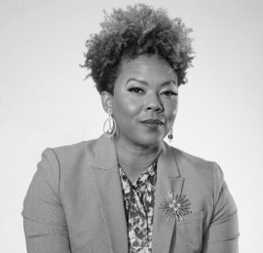
Nicole Price, PhD, Founder Lively Paradox
Dr. Price believes that it is impossible to be a good leader if you cannot work with difference. Being at the mercy of failed diversity and inclusion initiatives for years, she set out to “shake the gates” in her own way by founding Lively Paradox. The philosophy is rooted in the idea that adults who are ashamed are adults who cannot learn. As such, her programs seek to reduce shame in order to increase learnings.

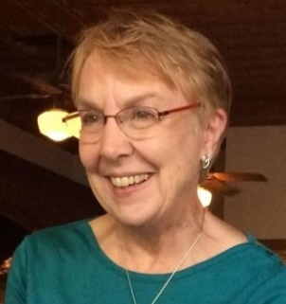
Katherine Campbell, CVA, Consultant
Katherine has worked in the field of nonprofit and volunteer management for over 30 years as practitioner, trainer, author, and leader. Her career began in 1973 at the Philadelphia Family Court where she helped develop an extensive volunteer program. For 14 years she worked at the Virginia Office of Volunteerism, eventually becoming director. From 1997 to 2003 she served as executive director of the international Association for Volunteer Administration (AVA). From 2006-2016 Katie served as Executive Director of the Council for Certification in Volunteer Administration (CCVA), managing professional credentialing programs for leaders of volunteers. She has taught at several Virginia colleges, and holds the Certified in Volunteer Administration credential. Katie is currently working part-time as an independent consultant and manages the local Service Enterprise program in Richmond, Virginia.

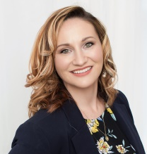
Callan Brown, MPA, Program Director at the Nonprofit Center of Northeast Florida
Callan works to strengthen the capacity of nonprofit organizations by planning and implementing a portfolio of initiatives that includes the Nonprofit Center’s professional development and board series, the annual Nonprofit Works Conference, and county-specific outreach strategies. Callan earned her Master’s Degree in Public Administration at the University of North Florida with a focus in Nonprofit Management and her B.A. in Art History from the Florida State University. Having worked for both small and large nonprofit organizations, Callan also has experience in development, grant writing and management, and before joining the Nonprofit Center, was the Program Director for Take Stock in Children Clay County at the YMCA of Florida’s First Coast.

Friday, October 23
Understanding Social Isolation

1:00 PM ET | Introduction Social Isolation
1:15 PM ET | Keynote  Understanding Social Isolation, with Lisa Marsh Ryerson, President AARP Foundation  Public awareness of social isolation has risen recently as people practice physical distancing to curb the spread of the coronavirus. Yet social isolation has long been a problem for older adults, and AARP Foundation—along with Shepherd’s Centers—has a longstanding commitment to eradicating it.
1:45 PM ET | General Session  What Is Social Isolation, Why It Matters, and How It’s Measured, with Emily Allen, Senior Vice President AARP Foundation  As the coronavirus thrusts millions of older adults into greater physical isolation from family, friends, and neighbors, it is more important than ever to understand the importance of social connections and strategies to support healthy social engagement and inclusion.
2:45 PM ET | Short Break
2:55 PM ET | Concurrent Sessions
 | Reaching Isolated, Underserved Communities, panel presentation  This panel will share their experiences reaching these often isolated populations and strategies for providing socially meaningful opportunities for all.  Betsy Solomon, Shepherd’s Center of Webster-Kirkwood, connecting with a historically black community  Lisa Carroll, Shepherd’s Center of Fairfax-Burke, connecting with Hispanic communities  Janet Seckel-Cerrotti, Friendship Works, connecting with LGBQ communities  Ann McClung, Shepherd’s Center of Greenbrier Valley, connecting with rural communities | The Care and Feeding of Your Staff, with Bill Hinman, Hinman Consulting  "...Curators [non-profit staff members], in the public mind, are obscure little people, happy at their work, who revel in being neglected and underprivileged...." S. Dillon Ripley, former Secretary of The Smithsonian Institution, reminds us that it is all-too-easy for board members to presume their staff members are happy to work long and hard hours at, ahem, modest pay. Truth is, they wouldn’t be there if they didn’t care deeply about what they do to help other people. However, in order to encourage, inspire, and receive maximum output and true job satisfaction, board members need to reflect carefully on what they are doing to recognize and reward their loyal staff members. This session will explore realistic, mostly non-monetary ways to help show the staff you really do care about them and that you appreciate their dedicated efforts.
4:00 pm ET | Short Break
4:10 PM ET | Concurrent Small Group Breakout Rooms  A unique opportunity to reflect on ideas presented throughout the day and dive deeper into questions with peers and colleagues.
5:15 PM ET | Enjoy the rest of your day!

Presenter Bios

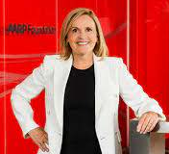
Lisa Marsh Ryerson, President AARP Foundation
A bold, disciplined and collaborative leader, Ms. Ryerson sets the Foundation’s strategic direction and steers its efforts to realize an audacious vision: a country free of poverty, where no older person feels vulnerable. During her tenure, she has spearheaded innovative partnerships with other organizations to create and advance effective solutions that help vulnerable older adults increase their economic opportunity and social connectedness.

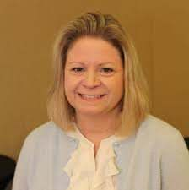
Emily Allen, Senior Vice President AARP Foundation
Ms. Allen leads a team of program innovators and social entrepreneurs to develop effective solutions that address the social determinants of health and help vulnerable, low-income older adults secure the essentials.

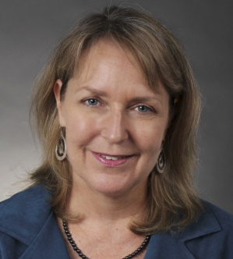
Joscelyn Silsby, Director of Evaluation AARP Foundation
Joscelyn has spent the past six years building the evaluation capacity of AARP Foundation, embedding evaluation practices within the Foundation’s strategic planning, innovation processes, funding decisions, grants management and legacy programs.

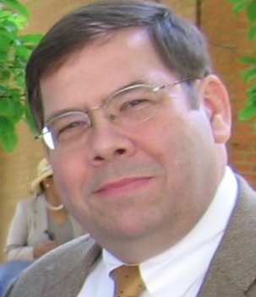
Bill Hinman, MBA, MA, CFRE, William Hinman Consulting
A veteran fundraiser and non-profit executive (as well as board member), Bill has provided professional consultative services – particularly in the areas of strategic planning, board/staff development, and capital campaign management – for 33 years, following 13 years in non-profit management. He has helped client organizations raise more than $135 million, attaining an average of 123% of fundraising goals. He holds MBA and MA degrees, had the distinction of being the first to earn his CFRE (Certified Fund Raising Executive) status in his region, and was recognized with a Lifetime Achievement Award by the Association of Fundraising Professionals (NC Triad Chapter). Bill applies his skills and experience to help non-profits achieve their worthy missions. Now a CFRE Emeritus consultant, Bill focusses his efforts on opportunities like Shepherd’s Centers of America which provide what he sees as invaluable and mission-critical services for society. He and four generations of his family live on a farm where they enjoy caring for a variety of livestock. When not consulting for non-profits, Bill makes custom furniture in his woodworking shop in one of the barns.

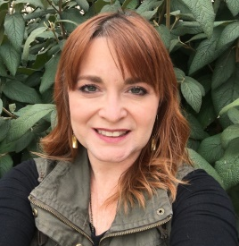
Betsy Solomon, MA, Executive Director Shepherd’s Center of Webster-Kirkwood and SCA Board of Directors
Betsy Solomon has worked in the rewarding non-profit world of programming for older adults for 25 years – including various roles at the Shepherd's Center beginning in 2007. Her prior professional life included Education Manager for St. Louis Regional OASIS as well as teaching and curatorial positions with the Saint Louis Art Museum and Laumeier Sculpture Park.

In addition to working with older adults, Betsy loves art and continues to teach a regular schedule of art history classes for St. Louis Community College, OASIS and various churches. Betsy and her husband Mike have two teenage children, two cats, and three fish. Betsy is also a BIG fan of the Dave Matthews Band.

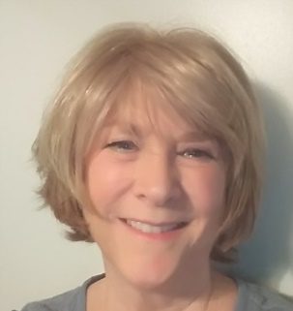
Lisa Carroll, Program Director Shepherd’s Center of Fairfax-Burke and Shepherd’s Center of South County
Prior to joining the Shepherd’s Center of Fairfax-Burke in Fairfax, VA, Lisa spent 23 years working with the United Way national headquarters. She has been in her current SCFB position for 10 years. Over the last decade, two milestones for SCFB, were the establishment of a new Shepherd’s Center in Western Fairfax County and the addition of a regional office in South County Alexandria.

Janet Seckel-Cerrotti, Executive Director of FriendshipWorks
Janet has been with FriendshipWorks (formerly MATCH-UP Interfaith Volunteers) in Boston since its inception in 1984—first as Coordinator of Volunteers and then Program Director, when FriendshipWorks was under the aegis of Boston Aging Concerns. She became the agency’s founding Executive Director when FriendshipWorks became an independent organization in 1991. In all of these capacities, she has been the driving force, creating a vision and steering the organization through its various stages of growth and development.

Janet holds an MSW degree from the Hunter College School of Social Work in New York, and is a graduate of Lead Boston (a program sponsored by the National Conference for Community & Justice). Janet has held a range of senior leadership positions in numerous organizations serving the needs of and advocating for the elderly. She is a founding member and former Board Chair of the National Volunteer Caregiving Network, has served as a board member of the Boston Partnership for Older Adults, is past-President of the Massachusetts Coalition on Spiritual Well-being of the Elderly and active member of the Multicultural Coalition on Aging. She is currently an active member of the MA Healthy Aging Collaborative Advisory Council, the MA Task Force to End Loneliness and Build Community.

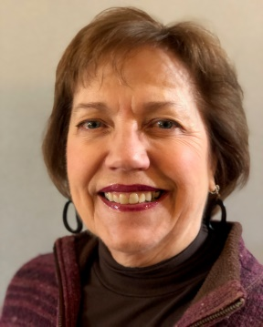
Ann McClung, Chair Shepherd’s Center of Greenbrier Valley, past Chair SCA Board of Directors
Ann is a retired Physical Therapist with a specialty in Geriatrics and Home Health. She chaired the organization of the Shepherd’s Center of Greenbrier Valley in 1999. She has served as President of SCA and Shepherd’s Center of Greenbrier Valley. Greenbrier County is in the south eastern corner of West Virginia and our center serves a rural population.
Monday, October 26
Examining Sustainability
of Aging Services

1:00 PM ET | Introduction to Sustainability
1:15 PM ET | Keynote  Finding Foundation and Corporate Funding for Aging Services: Using Aging as a “Lens” with John Feather  In an era when funding from traditional governmental sources for aging services is being reduced even as the population of older people grows rapidly, it is important for service providers to understand other sources of funding, particularly from the foundation and corporate world. Participants will learn how to use aging as a “lens” rather than a focus to find support outside of the very limited range of aging-specific funders.
1:45 PM ET | General Session  New Perspectives in Fundraising, with Bill Hinman  Pandemic, social distancing & masks, presidential election, supreme court vacancy, economic turbulence, protests & riots, hurricanes, wild fires–what a year 2020 has been! Meanwhile, at Shepherd’s Centers, how do we “make lemonade from lemons?” It is tough to raise support for our invaluable mission in these times, but a steady hand on the helm and adherence to time-tested best practices still matter. Explore some of the key elements of your fundraising plan that are perhaps more important now than ever before. How do you maintain donor relationships and sustain donor enthusiasm, train and equip your staff and volunteer solicitors, and articulate and share a vision for the essential importance of doing what Shepherd’s Centers across America do like nobody else does? We’ll use the lens of “new perspectives” to discover “timeless truths” and provide you with practical, applicable, and results-focused suggestions for keeping fuel in the tank even on the uneven highway of these tumultuous times.
2:45 PM ET | Short Break
2:55 PM ET | Concurrent Sessions
 | Social Media for Fundraising and Community Engagement with Charmaine Campo  This workshop provides an overview of social media platforms and how to use social media for meaningful engagement with the people you serve, your donors, and the broader community. You’ll learn more about what to post, when to post, and some of the different things you can post (such as photos, videos, events, and stories). Tips for fundraising success will be explored along with free tools to streamline your efforts. | Navigating Your Nonprofit Financial Landscape with Charles Smithers  This session explores what nonprofit board members, leaders, staff, and volunteers need to know about a nonprofit's financial position, oversight, and reporting requirements. In this workshop, you’ll learn what makes up a financial reporting package and how to make sense of the numbers and supplemental information. You’ll gain a better understanding of the IRS Form 990, and what it conveys about your mission and finances.
4:00 PM ET | Short Break
4:10 PM ET | Concurrent Small Group Breakout Rooms  A unique opportunity to reflect on ideas presented throughout the day and dive deeper into questions with peers and colleagues.
5:15 PM ET | Enjoy the rest of your day!

Presenter Bios

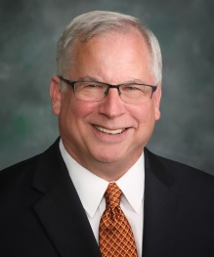
John Feather, Ph.D., Chief Executive Officer Grantmakers in Aging
John has served as CEO of Grantmakers In Aging, the national association of grantmaking foundations and other organizations that work to improve the lives of older people, for the last 9 years. Dr. Feather is currently on the Board of Archstone Foundation and EngAGE. He is the Past Chair of the Board of Directors of the American Society on Aging and a former officer or Board member of 15 other national nonprofit organizations.

He received the ASA Award from the American Society on Aging for his work in policy, practice and education, and was elected a Fellow of the Gerontological Society of America. He was selected as one of the “50 Influencers in Aging” by Next Avenue, PBS’ national information source on aging, received the Ophelia Rinaldi Lifetime Achievement Award from National Hispanic Council on Aging, and was elected to the National Academy of Social Insurance. He recently joined the faculty of the Steve Hicks School of Social Work at the University of Texas at Austin.

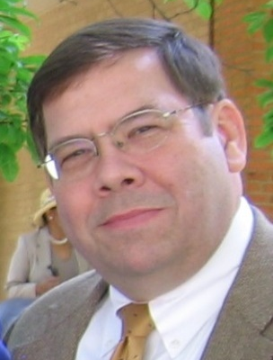
Bill Hinman, MBA, MA, CFRE, William Hinman Consulting
A veteran fundraiser and non-profit executive (as well as board member), Bill has provided professional consultative services – particularly in the areas of strategic planning, board/staff development, and capital campaign management – for 33 years, following 13 years in non-profit management. He has helped client organizations raise more than $135 million, attaining an average of 123% of fundraising goals. He holds MBA and MA degrees, had the distinction of being the first to earn his CFRE (Certified Fund Raising Executive) status in his region, and was recognized with a Lifetime Achievement Award by the Association of Fundraising Professionals (NC Triad Chapter). Bill applies his skills and experience to help non-profits achieve their worthy missions. Now a CFRE Emeritus consultant, Bill focusses his efforts on opportunities like Shepherd’s Centers of America which provide what he sees as invaluable and mission-critical services for society. He and four generations of his family live on a farm where they enjoy caring for a variety of livestock. When not consulting for non-profits, Bill makes custom furniture in his woodworking shop in one of the barns.

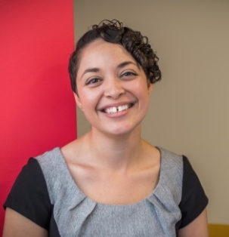
Charmaine Campo, Owner & Founder, Do Good Communications LLC
Are you tired of depending on word of mouth and answering numerous phone calls and emails asking about your programs and services, but you can’t get them to engage long-term? At Do Good Communications, Charmaine has developed a custom approach that takes all of the frustration and uncertainty out of Digital Marketing for nonprofits. She has helped nonprofits grow social audiences, increase brand recognition/public support, and engage audiences consistently and predictably. A graduate of the University of North Florida and lifelong learner, Charmaine knows what it takes to create an effective strategy and implement it for you so you don’t have to feel like you just don’t know where to start with your social media marketing online. At Do Good Communications, Charmaine is on a mission to help nonprofits build meaningful connections online, so they can focus on what's most important: making a difference in the lives of others.

Check out a few of Charmaine’s social media campaigns: Teachers Are More (over 100,000 engagements) and
Focus On The Paw-Sitive (over $24K raised in less than 24 hours).

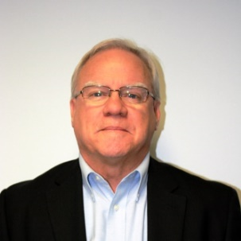
Charles W. “Chuck” Smithers, Jr., CPA/CGMA
Chuck is a Certified Public Accountant and a Chartered Global Management Accountant who has spent most of his professional career (47 years) in the not-for-profit and health care industries. Although now partially retired, Chuck continues to be involved in the health care policy and finance arena as an independent consultant. Concurrent with his career he has made a point of being involved in volunteer work with a number of not-for-profit organizations, most recently with Shepherd’s Center of America (Treasurer and Board Member) and Shepherd’s Center of Orange Park (Finance Director and Advisory Board Member).

Wednesday, October 28
Inspiring Creative Solutions

1:00 PM ET | Creative Solutions Introduction
1:15 PM ET | Keynote  Making the Most of the Multigenerational Society with Marc Freedman, President and Founder Encore.org  For the first time in history, there are more people in the U.S. over 60 than under 18. To make the most of this multigenerational society, bridge divides and build strong communities, we’re going to have to reimagine the institutions of daily life, from housing to education, caregiving to health care and work. Encore.org CEO Marc Freedman will provide a series of examples of innovative, intergenerational solutions – including Nuns & Nones, Big & Mini, and Grandmas2Go -- that could be game changers for all of us.
1:45 PM ET | General Session  The Talk: Its more THAN words with Lana McKinney  This general session helps navigate the conversation between caregivers and loved ones about what is included in an advance care plan. These practical approaches to the conversation provide insight to all parties on the how, why, and what to ensure no matter the stage of life your loved one’s legacy has sustainable means.
2:45 PM ET | Short Break
2:55 PM ET | Concurrent Sessions
 | Intergenerational Service Learning: Increasing Cultural Competency and Decreasing Ageism, with Oren Renick. Randall Osborne, and Zo Ramamonjiarivelo  This team at Texas State University reviews how they documented the mutual benefits of intergenerational service learning for both students and older adults. Students provided practical services to older adults to help them maintain their independence and autonomy. These students showed an increased commitment to civic engagement while older adults showed an increased capacity to maintain an independent lifestyle. Join this session to learn more about multicultural sensitivity by students, attitudes on ageism, and the value of intergenerational opportunities. | Creative Strategies for Service Delivery, panel presentation  This panel will share their ideas for delivering services in new ways to continue to advance the mission.  Lindy Harrell, LifeQuest, creating dynamic lifelong learning classes  Rebecca Gordon, Northland Shepherd’s Center, creating contactless but heartwarming drive-through services  Lauren Guynn, Shepherd’s Center of Hamilton County, creating connections with technology  Holly Whitfield, Shepherd’s Center of Charlotte, creating successful virtual fundraisers
4:00 PM ET | Short Break
4:10 PM ET | Concurrent Small Group Breakout Rooms  A unique opportunity to reflect on ideas presented throughout the day and dive deeper into questions with peers and colleagues.
5:15 PM ET | Enjoy the rest of your day!

Presenter Bios

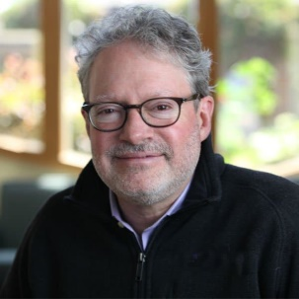
Marc Freedman, President, CEO and Founder of Encore.org
Marc is one of the nation’s leading experts on the longevity revolution. The Wall Street Journal named his newest book — How to Live Forever: The Enduring Power of Connecting the Generations (PublicAffairs/Hachette Book Group, 2018) — one of the year’s best books on aging well. An award-winning social entrepreneur, frequent media commentator and author, Freedman is widely published in the national media and has been honored with numerous awards and fellowships, including the Eisner Prize for Intergenerational Excellence. Originator of the encore career idea linking second acts to the greater good, Freedman helped create Experience Corps, the Purpose Prize, and Encore Fellowships.

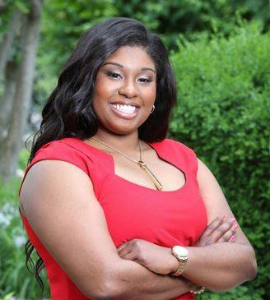
Lana McKinney, Founder of Wrightshands
Lana McKinney is a certified gerontologist working to help increase resources for adults age 60 years and older along with their families. She consults on advance care plans and caregiving the Greater Kansas City Metropolitan area. Her passion for connecting with people is to bridge the gap of wisdom for the next generations. She is a published author and her book entitled “Make It Wright: Stories and Steps on Eldercare” is used by local senior communities to open up the conversations on aging to all members of any family. She welcomes collaborations and believes to ensure the future the power lies in the policy. She serves as the Vice Chair for the Health Forward Foundation Community Advisory Council and makes public policy recommendations to the Silver Haired Council of Kansas City, Missouri. Lana is currently a doctoral candidate at the University of Nebraska focusing on geriatric public policy.

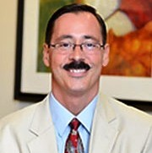
Randall E. Osborne, Ph.D., Professor of Psychology and Honorary Professor of International Studies at Texas State University
Dr. Osborne teaches a wide range of courses including a Sports Psychology, Forensic Psychology and a course on Prejudice, Discrimination and Hate. His emphasis in teaching has always been on critical thought and analysis—fully believing that critical thinking skills are important life skills. He has incorporated service-learning into his courses for over 20 years and his scholarship of teaching research interests focus on documenting the effects of service learning on students (and on their learning, in particular), how to facilitate Intercultural Sensitivity in students and how to approach sensitive topic courses that encourage open and honest self- analysis in students without inviting or condoning “us versus them” thinking.

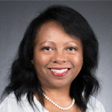
Zo Ramamonjiarivelo, MBA, Ph.D., Associate Professor Health Administration at Texas State University
Dr. Ramamonjiarivelo has taught several undergraduate and graduate courses in health administration, such as health care statistics, managerial epidemiology, health policy, strategic management, research methods, organizational behavior, and health care quality improvement, among others. She thinks teaching is a rewarding profession, especially when she sees the career success of her students. Dr. Ramamonjiarivelo’s research interests include the factors associated with strategic decision making of health care organizations and the impact of such decisions on organizational performance, as well as health disparities, health care quality and patient experience.

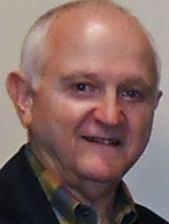
Oren Renick, Th.M., J.D., Professor Health Administration at Texas State University
Rev. Dr. Oren Renick is a Professor of Health Administration at Texas State University. Previously he served as Director of the Texas Long Term Care Institute and simultaneously as Chair of the Department of Health Administration and Interim Chair of the Department of Health Services Research. He served as Founding Director of the Service-Learning Initiative and Chair of the Faculty Senate. Prior to coming to Texas State, Renick was the chief executive of three healthcare organizations including managed care organizations in Chicago and New Orleans. Renick has been principal investigator for grants and contracts totaling approximately $5,000,000. His major scholarly interests are civil rights, service learning and civic engagement, health care law and ethics, managed health care delivery systems, and baseball and American culture. He is Executive Editor of the book on intergenerational service learning entitled The Ties That Bind. The second edition of his book, Smoke Over Mississippi, was released in 2020. It concerns civil rights and radical reconciliation.

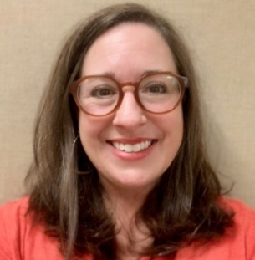
Lindy Harrell, Executive Director LifeQuest of Arkansas
Interim Executive Director Lindy Harrell joined LifeQuest of Arkansas, as the Office Manager, in 2016. In February, the Board of Directors appointed Harrell as Interim Executive Director. A native of Little Rock, Arkansas, Harrell graduated from the University of Arkansas in 1990, with a Bachelor of Arts, in Psychology.

Harrell has always had a passion for helping people. First, as an interior decorator with her own business, then, as the Billing Manager for a pediatric clinic. It was here Harrell found her love for medicine. She always joked, after raising four children and the experience she gained from the clinic, she should have received an honorary medical degree with the name Dr. Quack. In 2012, Harrell and her husband moved back to Little Rock to be closer to aging parents. She developed a love for the senior community and joined the LifeQuest of Arkansas staff. As Interim Executive Director, she and the team at LifeQuest have developed an online curriculum, keeping seniors engaged mental, physically, spiritually and emotionally, from the safety of their homes. The LifeQuest of Arkansas online curriculum reaches participants throughout the United States and overseas.

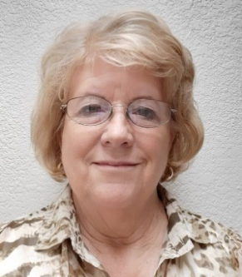
Rebecca Gordon, Executive Director Northland Shepherd’s Center
Rebecca started working at Northland Shepherd’s Center (NSC) as an office volunteer 22 years ago. Her mother-in-law was heading the Adventures in Learning program and her father-in-law was on the board. After volunteering for two years, she was asked to become a part time employee; then two years later, the Executive Director position opened, and she was asked to step into the role. With a great team by her side, Rebecca has had the privilege of serving as the Executive Director for 19 years.

In 2019, NSC moved into their new home, a building that they bought and renovated. Before the pandemic, NSC offered 20 different services and programs to those 60 and older – helping them to stay in their own homes and thrive. Since COVID-19, staff has been thinking outside the box in different ways to continue meeting the needs of older adults. Some services, such as Meals on Wheels, have continued uninterrupted, while others have been offered outside or as drive thru activities. As they continue to serve more people, a focus is on creating a Virtual Technology Lab to help older adults learn how to use their iPhones, iPads, and tablets.

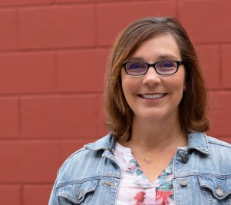
Jennifer Miller, Director of Operations Shepherd’s Center of Hamilton County
Jennifer joined the team at Shepherd’s Center of Hamilton County in March of 2020, quickly becoming the Director of Operations. She has an undergraduate degree in Natural Resources Management from Grand Valley State University in Allendale, MI, and a graduate degree in Urban Planning from Wayne State University in Detroit, MI. She earned her American Institute of Certified Planners certificate in 2009. Jennifer worked in local government for over 16 years before transitioning to the nonprofit sector. Initially working for an affordable housing developer, her passion for working with the young at heart soon became evident. She is excited to be part of an organization where her diverse experience is utilized every day helping the residents of Hamilton County.

In her off-time Jennifer is a multi-sport athlete. She and her husband of 20 years are avid motorcyclists. Their three rescue dogs, Helmet, Radar and Moxie, take up any and all remaining down time.

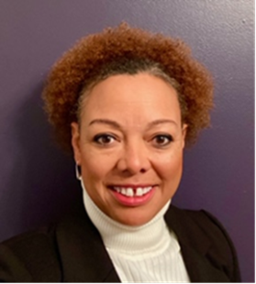
Holly Whitfield, Executive Director Shepherd’s Center Charlotte
Holly Whitfield has a breadth of nonprofit experience from small and large organizations. She is currently the Executive Director of the Shepherd Center of Charlotte. Additionally, Ms. Whitfield is a PhD candidate within the field of Industrial and Organizational Psychology working with a research topic of formal and informal feedback correlation to employee turnover intentions within the nonprofit sector. Utilizing these skills, she not only provides her expertise as an organizational consultant, she also devotes time to teaching undergraduate students as an adjunct professor within the area of program design and evaluation, an applied research science course. Additionally, she serves as a VP of Inclusion, Diversity, Equity, and Access on the board of directors for the Association of Fundraising Professionals - Charlotte Chapter.

Friday, October 30
Celebrating Aging

1:00 PM ET | Conference Review
1:10 PM ET | Exclusive Premiere  Lives Well Lived celebrates the incredible wit, wisdom, and experiences of people aged 75 to 100 years old. Through their intimate memories and inspiring personal histories encompassing over 3,000 years of experience, forty people share their insights on living a meaningful life. These men and women open the vault on their journey into old age through family histories, personal triumph and tragedies, loves and losses—seeing the best and worst of humanity along the way. Their stories will make you laugh, perhaps cry, but mostly inspire you. Enjoy a front row seat to this critically acclaimed, award winning documentary.
2:15 PM ET | Q&A with Sky Bergman
2:35 PM ET | Short Break
2:45 PM ET | Awards Celebration
3:45 PM ET | Closing Ceremony

Thank you for joining our 2020 virtual conference!

Presenter Bio

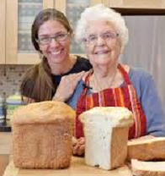
Sky Bergman, Filmmaker
Sky Bergman is an accomplished, award-winning photographer. Lives Well Lived is Sky’s directorial debut. Her fine art work is included in permanent collections at the Los Angeles County Museum of Art, The Brooklyn Museum, the Seattle Art Museum, the Santa Barbara Museum of Art, and the Bibliothèque Nationale de France (National Library of France) in Paris. Her book, The Naked & The Nude: Images from the Sculpture Series, includes an introduction by Hèléne Pinet, curator of photography at the Rodin Museum in Paris. She has shot book covers for Random House and Farrar, Straus & Giroux, Inc., and magazine spreads that appeared in Smithsonian, Arthur Frommer’s Budget Travel, Reader’s Digest, and Archaeology Odyssey. Ms. Bergman currently is a Professor of Photography and Video at Cal Poly State University in San Luis Obispo, CA. Pictured here with 103-year-old Grandmother, Evelyn Ricciuti, the inspiration for Lives Well Lived.

